Assignment 3
Date Assigned: 03/30/2017
Due: Midnight 04/12/2017 on iLearn

Please read turn-in checklist at the end of this document before you start doing exercises.
Section 1: Pen-and-paper Exercises

- Using the iteration method discussed in class, find a tight bound for the solution of the following recurrence equation. Assume that you know that 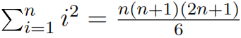, and 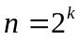(n is a power of 2).
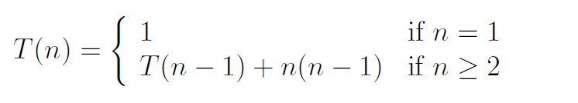
Note: Credit will not be given only for answers - show all your work:
(5 points) steps you took to get your answer.
(5 points) your answer.

- Analyze the following code and provide a "Big-O" estimate of its running time in terms of n. Explain your analysis.

int k = n;
while (k > 0) {
for (int j=0; j < n*n; j++)
sum += data[j];
k = k / 2;
}

Note: Credit will not be given only for answers - show all your work:
(5 points) steps you took to get your answer.
(5 points) your answer.

- Consider the following problem (30 points):
Given k sorted lists, design an algorithm to merge them into one sorted list. Assume n is the total number of elements in all the input lists. Analyze your algorithm’s running time.
Important: In all of the assignments of this course, when you are asked to give an
algorithm for a problem, you are (unless otherwise indicated) expected to
(i) describe the idea behind your algorithm in English (10 points);
(ii) provide pseudocode (10 points);
(iii) analyze its running time (10 points).
Regarding requirement (iii): Unless otherwise specified, show the steps of your analysis
and present your result using big-O.

- Trace Merge Sort on the following array:
{1, 7, 6, 8, 0, 2, 5}
Note: Write down the state of the array after each recursive call. (5 points).

- Trace Quick Sort on the following array:
{11, 7, 6, 48, 30, 12, 75}
Note: Write down the state of the array after each recursive call. For each recursive call, let the pivot be the leftmost element/first element in the subrange (5 points).

- Assume there is an array A that consists of n elements, each of which is red, white, or blue. We seek to sort the elements so that all the reds come before all the whites, which come before all the blues. Your algorithm should run in O(n) time in the worst case.
Hint: Use the Partition idea.
Full credit (30 points) will be awarded for an algorithm that is O(n). Algorithms that are O(nlogn) or slower will be scored out of 20 points.

- Input: A list of non-negative integers.
Output: Arrange integers such that they form the largest number.
For example, given [3, 30, 34, 5, 9], the largest formed number is 9534330.
Design an algorithm to solve this problem (30 points).
Note: The result may be very large, therefore you need to return a string instead of an integer.

Section 2: Java Implementation
- Assume k = 3, implement problem 3 in Java (30 points).
Note:
Find a file called Problem3.java in assignment 3 folder.
Complete the method of mergeklists().
Test your method in the main method provided following the comments.

- Implement problem 7 in Java (30 points).
Note:
Find a file called Problem7.java in assignment 3 folder.
Complete the method of largestnumber().
Test your method in the main method provided following the comments.

TURN-IN CHECKLIST:

- Answers to Section 1 (.doc/.txt), and to Section 2 (all your source Code (.java files)). Remember to include your name, the date, and the course number in comments near the beginning of your code/report.

- Create a folder and name it 'FirstName_LastName_assignment_3'. In the newly created folder copy and paste your files (.doc/.txt/.java files). Then compress the folder, and submit to iLearn.

